prototype with familiar and unfamiliar navigation elements
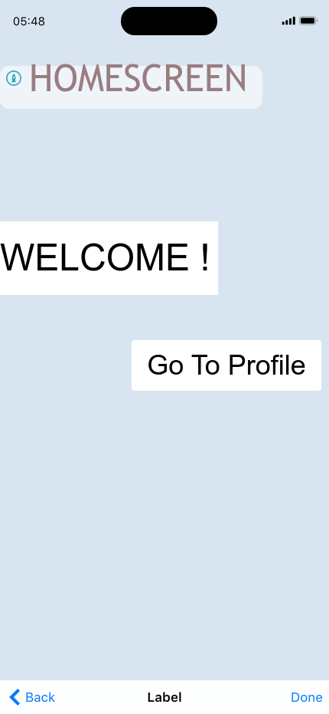

- HomeScreen with an welcome screen
- Header widget with a go to profile

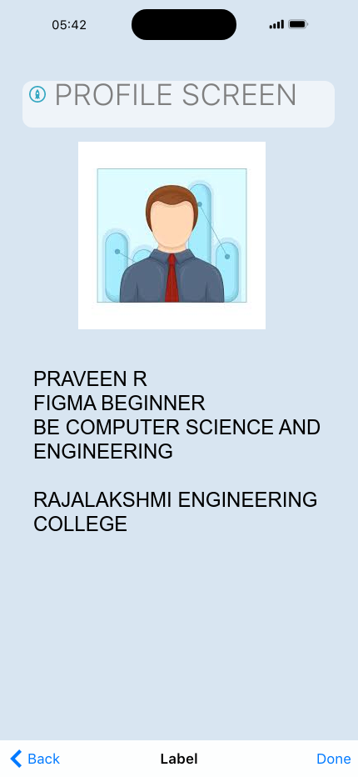

- My profile Photo
- My Profile Details
- If click on back ,will navigate to the homescreen

